San Francisco Metropolitan Area

Student’s Name
Institutional Affiliation
Course Number

Author Note
Table of Contents
Introduction 3
Physical Geography 3
Demography 4
References 8
Appendix 9

San Francisco Metropolitan Area
San Francisco Metropolitan Area (SFMA) is a cosmopolitan district in California surrounded by the San Francisco Bay and the Pacific Ocean. SFMA consists of five counties categorized into Livermore, Berkeley, and Oakland divisions, including Contra Costa, San Mateo, San Francisco, Alameda, and Marin, as shown in figure 1. SFMA has a population of approximately seven million people, with an average median household income of one hundred and eight thousand dollars (Boeing, 2018). Overall, the metropolitan area is a strategic region with stable economic growth, a synergistic innovative population, a fascinating culture, and advanced infrastructure. Thus, this research paper provides a concise geographic profile of the San Francisco Metropolitan area, describing its climate, landscape, population, economics, and lifestyle.
Physical Geography
Topographical factors are the most critical aspects in defining the climate and weather of SFMA. For example, the region is characterized by hot summers and rainy winters (Mujahid et al., 2019). SFMA lies approximately 22m above sea level with an average temperature of 14.1℃ and an annual rainfall of 547mm (Mujahid et al., 2019). On the other hand, snowfall is rare, and frost occurs occasionally. Short periods of freezing are experienced between November and April. Specifically, Coastal regions have a more moderate climate than the interior, which is associated with significant moisture from fog formed during the summer (Mujahid et al., 2019). Changes in the weather patterns cause disparities in the onset of growing seasons. Human practices also change the frequency and intensity of climate-related events through increasing sedimentation, pollution, and salinities. SFMA is projected to experience increased sea levels to about 0.9398 meters and augmented precipitation in the next 100 years because of human activities (Mujahid et al., 2019). SFMA is hilly with notable natural features such as Mount Davidson, Rincon Hill, Telegraph Hill, and Mount Sutro (Stehlin, 2016). The west side of SFMA consists of sand dunes, while the east side is mainly marshy. The Bay Area has unique animals that fill virtually all the ecological niches in the animal kingdom, such as white sharks, sea lions, river otters, garter snakes, brush rabbits, and fox squirrels (Mujahid et al., 2019). In this regard, SFMA climate offers long growing seasons, supports diverse plant and animal species, and fosters economic growth.
Demography
SFMA is the most populous district in California and the second highest inhabited area in the United States. SFMA has a population density of approximately one thousand nine hundred and twelve people per square mile in a land area of 64,000 km². The original inhabitants settled in the SFMA in the 3000 B. C, and by the 16th century, the Yelamu tribe inhabited the region (Boeing, 2018). Currently, communities of color are the majority of the inhabitants of the area, with an increase from 30 to 59% (Boeing, 2018). The region registers a 1.2% annual population growth, which is 50% above the national population growth rate (Boeing, 2018). For example, the population increased from 5 to 8 million people between 1980 and 2014 (Boeing, 2018). However, SFMA has experienced a 0.6% decline in the population growth owing to the decreasing fertility rates since 2015. Non-Hispanic Whites are the largest group, followed by Latinos, Asians, and Pacific Islanders. For instance, Asians account for 25%, and Pacific Islanders register 23% of the growing population with Indian, Filipino, and Chinese ancestries forming the most significant subgroups (Boeing, 2018). The Latinos are predominantly of Mexican descent, with a small proportion of Salvadoran lineage. Marin is the least diverse among the nine counties. Therefore, SFMA is a cosmopolitan area with a high population growth rate.

Economic Geography
The region’s diversity is a tremendous economic asset due to the availability of a sufficient and talented workforce. The area is a hub for diverse companies such as Apple, Facebook, and Salesforce corporations. The San Francisco Metropolitan Area is the center for the manufacture of electronics and the development of information technologies. The Silicon Valley forms the principal node of corporate headquarters. Approximately one-fifth of the population is employed in the manufacturing, administrative, and healthcare industries. Workers in the area have an average hourly wage of thirty-five dollars (Glaeser & Gyourko, 2018). Local employment is mainly concentrated in mathematical, financial operations, business management, and computer technology occupations. Software developers, information research scientists, and computer-user-support specialists are some of the highest-paid careers with an hourly wage of seventy dollars (Glaeser & Gyourko, 2018). Hence, the region’s GDP grew from $308.2 billion to $497.2 billion between 2001 and 2018, as depicted in figure 2. In summary, the SFMA employment base is remarkably diverse, and the majority of residents working in the information technology sector.
Socio-Cultural Geography
SFMA is a region along the Pacific Ocean that consists of spectacular views of the hills and waterfronts. The residents enjoy an abundance of the natural beauty of surrounding parks, lakes, and vistas (McNeill, 2016). The region offers a great urban environment with the capacity to exist in harmony with its natural surroundings. SFMA encompasses diverse parks, about 26 recreation centers, 160 baseball fields, 10 swimming pools, 150 tennis courts, 130 playgrounds, 25 miles bike trails, a music grove, and a carousel (McNeill, 2016). The majority of tourists are attracted by the unique park system, which has enhanced the economy of the SFMA. San Francisco Pride Festival, Yerba Buena Gardens Festival, Escape from Alcatraz Triathlon, and the Hardly Strictly Bluegrass Festival are among the most famous outdoor events that attract locals and foreigners to the parks (McNeill, 2016). Some universal parks include the Civic Center Plaza, Golden Gate, and the Japantown Peace Plaza (McNeill, 2016). In this regard, the convergence of lifestyle trends, cultural preferences, and technological advancements render SFMA an exciting place to explore and reside
Conclusion
SFMA is situated along the Pacific Ocean and consists of distinctive parks that are critical sources of income along with schools, churches, and other social gathering spaces. The major occupations in the region include business managers, research scientists, computer technologists, and electronic manufacturers. The unique natural resources, favorable weather patterns, and a diverse population make SFMA an exciting place to explore. The tourism, manufacturing, and agriculture sectors have great potential to grow following the initiative of the federal government to protect the remaining resources from encroachment. In brief, SFMA is an attractive place for foreigners owing to its unique recreation opportunities, cultural diversity, and economic productivity.
References
Boeing, G. (2018). Estimating local daytime population density from census and payroll data. Regional Studies, Regional Science, 5(1), 179–182. doi.org/10.1080/21681376.2018.1455535
Glaeser, E., & Gyourko, J. (2018). The economic implications of housing supply. Journal of Economic Perspectives, 32(1), 3-30. doi=10.1257/jep.32.1.3
McNeill, D. (2016). Governing a city of unicorns: Technology capital and the urban politics of San Francisco. Urban Geography, 37(4), 494–513. doi:10.1080/02723638.2016.1139868
Mujahid, M. S., Sohn, E. K., Izenberg, J., Gao, X., Tulier, M. E., Lee, M. M., & Yen, I. H. (2019). Gentrification and displacement in the San Francisco Bay Area: A comparison of measurement approaches. International Journal of Environmental Research and Public Health, 16(12), 1-13. doi:10.3390/ijerph16122246
Stehlin, J. (2016). The post-industrial “Shop Floor”: Emerging forms of gentrification in San Francisco’s innovation economy. Antipode, 48(2), 474–493. doi:10.1111/anti.v48.2
Walker, R., & Schafran, A. (2015). The strange case of the Bay Area. Environment and Planning A, 47, 10–29. doi:10.1068/a46277

Appendix
Figure 1
San Francisco Metropolitan Area Map (US Censures Bureau, 2018)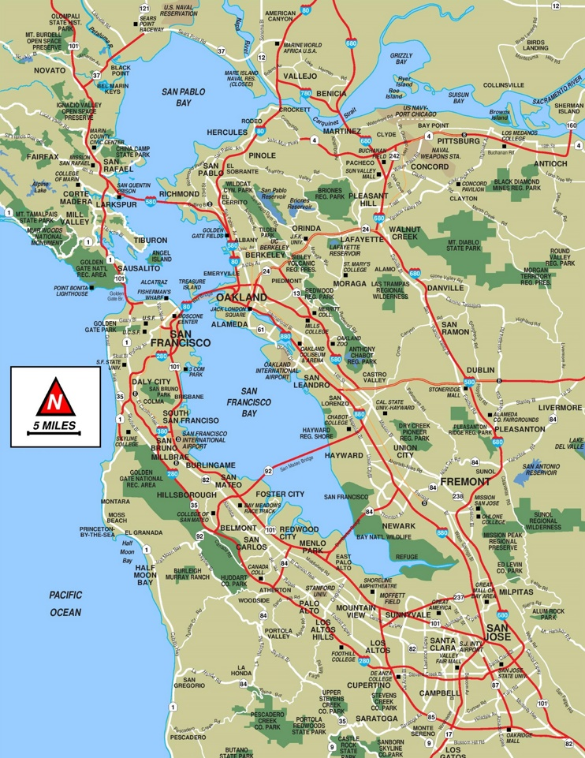
Figure 2
GDP of the San Francisco Metropolian Area from 2001 to 2018 (US Census Bureau, 2018)

